
Data Security Envisioning Workshop
09-Module Delivery Guide-Data Security for AI
v8.5 - January 2026

Contents
Disclaimer 3
Version history 4
We look forward to your feedback! 4
1 Introduction 5
1.1 Objectives 6
1.2 Delivery guidance 6
1.3 Scoping 6
1.4 Estimated partner effort 7
1.5 Tools and services used 7
1.5.1 Microsoft Purview Data Security Posture Management for AI 7
1.6 DSPM for AI requirements 8
2 Activity details 9
2.1 Step 1 - Kick-off meeting 9
2.2 Step 2 - Acquire and assign licenses. 10
2.3 Step 3 - Setup and configuration 11
2.3.1 Verify Microsoft Purview Audit is turned on 12
2.3.2 Install the Microsoft Purview browser extension 13
2.3.3 Onboarding devices to Microsoft 365 14
2.3.4 Extend insights for data discovery 17
2.4 Step 4 - Analyze the findings 22
2.5 Step 6 - Decommission 28

Disclaimer
The Data Security Envisioning Workshop provides a summary of an organization’s data protection and compliance stature and recommendations to improve data protection and compliance.
The information, results, and scoring provided through the Data Security Envisioning Workshop are recommendations and provided for general informational purposes only. They do not constitute legal advice, certifications, or guarantees regarding regulatory compliance; it is up to each organization to evaluate the effectiveness of these recommendations in their respective regulatory environment prior to implementation. Organizations should consult with their own legal professionals to determine how standards or regulations apply to their organization and how to best ensure compliance.
We hope the Data Security Envisioning Workshop helps identify technologies and additional steps that organizations can implement to simplify their compliance efforts.
MICROSOFT MAKES NO WARRANTIES, EXPRESS, IMPLIED, OR STATUTORY, AS TO THE INFORMATION IN THIS Data Security Envisioning Workshop. Microsoft disclaims any conditions, express or implied, or other terms that use of the Microsoft products or services will ensure the organization’s compliance with regulations or standards. This Data Security Envisioning Workshop Toolkit is provided “as-is.” Information and recommendations expressed in the Data Security Envisioning Workshop Toolkit may change without notice.
The Data Security Envisioning Workshop Toolkit does not provide the user with any legal rights to any intellectual property in any Microsoft product or service. Use of the tool is for internal, reference purposes only; however, Microsoft partners may distribute the Data Security Envisioning Workshop Toolkit to their customers for such customers’ internal, reference purposes only. Any distribution of the Data Security Envisioning Workshop Toolkit by a Microsoft partner to its customers must include terms consistent with those set forth in this disclaimer.
© 2026 Microsoft. All rights reserved.

Version history
Version | Author | Changes | Date
7.0 | François van Hemert | First release of additional module on Generative AI | January 2025
7.1 | François van Hemert | Version number update, no further changes | May 2025
8.0 | François van Hemert | Update to align with current product features and functionality (evergreen), update name, update branding. | July 2025
8.5 | François van Hemert | Update to align with current product features and functionality (evergreen) | January 2026


We look forward to your feedback!
Thank you for your continued trust and partnership. The resources within this toolkit will be iteratively improved upon based on product releases as well as direct feedback from delivered engagements. We encourage you to provide feedback to help us improve our products and toolkits.
Please share your feedback and questions via our Engagement feedback form that can be found at: https://aka.ms/SCIEngagementsFeedback.

Introduction
This document contains delivery guidance for the optional Data Security for AI activity that will extend the Automated Discovery Process with insights into generative AI usage and potential associated data security risks within your organization.
The Data Security for AI activities are organized around 3 scenarios that depend on which AI applications the customer is using and what features they have enabled:
Scenario 1 - Shadow AI / 3rd party generative AI.
The customer has not yet implemented a corporate generative AI solution and seeks to understand the frequency and extent of users' utilization of publicly available, unmanaged, and unsanctioned AI solutions. The Data Security for AI activity will provide insights and analytics into the usage of third-party public generative AI applications.
Scenario 2 - Microsoft 365 Copilot interactions.
The customer has implemented Microsoft 365 Copilot and seeks to understand user interactions with it. The Data Security for AI activity will offer insights into its usage, data sensitivity, and related security risks.
Scenario 3 - Identify data oversharing risks.
The customer is planning to deploy a generative AI solution in his/her organization and wants to understand the risks of data oversharing. The Data Security for AI activity will evaluate the top 100 SharePoint sites in the organization and report on over-permissioned and overshared data.
The outcome and findings of this activity will be merged into the overall findings and recommendations that will be presented at the end of the Data Security Envisioning Workshop.

Objectives
The objectives for this activity are:
- Obtain comprehensive insights and analytics regarding AI activities within your organization.
- Analyze data stored in SharePoint Online to identify possible cases of oversharing.

Delivery guidance
This document is an integral part of the overall delivery guidance for the Data Security Envisioning Workshop. When delivering the Data Security Check, follow the guidance provided in the <00-Master Delivery Guide> and when instructed, engage in the supplemental activities outlined in this guide.
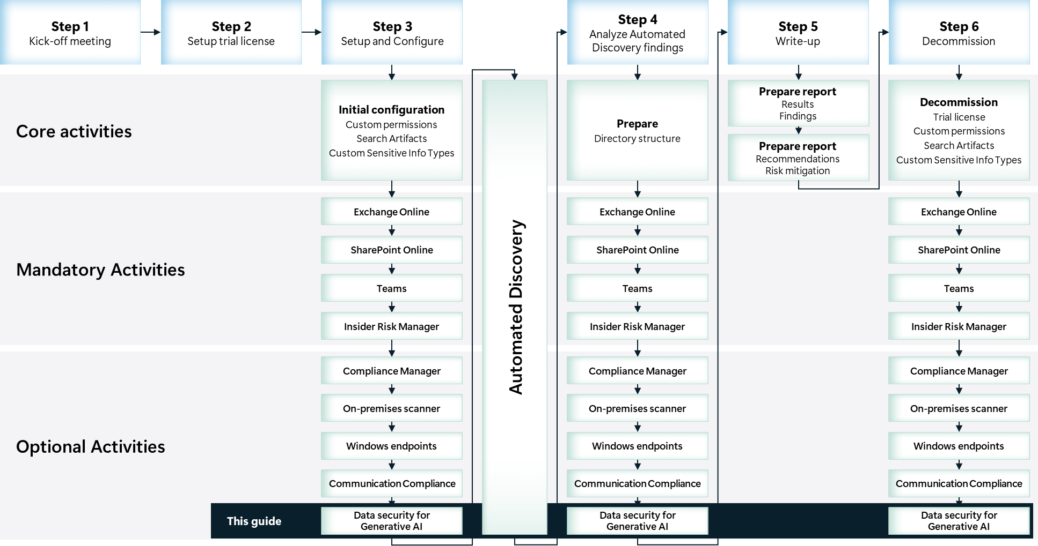

Scoping

In scope
The scope for this activity includes:
- Enable and configure Microsoft Purview Data Security Posture Management for AI.
- Install the Microsoft Purview browser extension on workstations of users participating in the Data Security Envisioning Workshop.
- Onboard Windows 11 devices to Microsoft Purview portal.
- Extend the insights for data discovery to collect information about users visiting third-party generative AI sites and sending sensitive information to them.
- Run a data assessment for the top 100 SharePoint sites used by Microsoft 365 Copilot to identify potential oversharing of data.

Estimated partner effort
The table below provides a high-level estimate of the additional partner effort for the activities described in this guide. The numbers provided are to be considered indicative and can change as a result of customization of the delivery schedule and the individual activities.
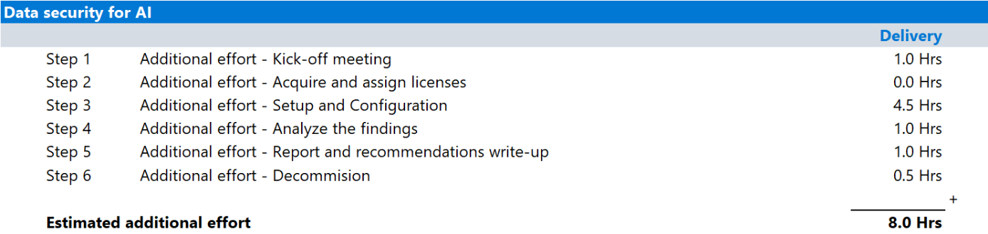

Tools and services used
The Data Security Check Automated Discovery process leverages Microsoft Purview Data Security Posture Management for AI to discover and report on AI usage of both Microsoft 365 Copilot and AI apps from third-party large language modules (LLMs). Additionally, the Data risk assessments functionality will be used to identify potential oversharing risks in the customer’s organization.

Microsoft Purview Data Security Posture Management for AI

Overview
Microsoft Purview Data Security Posture Management for AI (DSPM for AI) can help protect AI models, data, and applications from various threats. It provides visibility into AI systems, identifying sensitive data and monitoring its usage. DSPM for AI continuously assesses vulnerabilities and misconfigurations, helping to mitigate risks like data leaks and adversarial attacks. It enables real-time detection and response to security incidents, ensuring prompt action against data exposure or misuse. Additionally, DSPM for AI ensures compliance with data protection regulations, maintaining a strong security posture. The benefits include enhanced security, operational efficiency, regulatory compliance, and improved trust in AI systems.

Product information
For detailed information refer to:
- Microsoft Purview – Data Security Posture Management (DSPM) for AI
- Microsoft Purview data security and compliance protections for generative AI apps
- Strengthen your data security posture in the era of AI with Microsoft Purview

Functionality used by the Data Security Check.
Data Security Check leverages DSPM for AI to:
- Analyze and provide insights into users accessing Microsoft 365 Copilot and/or third-party generative AI websites.
- Reveal Shadow AI by identifying access to un-managed or un sanctioned third-party generative AI websites.
- Identify risks associated with copying sensitive information to AI platforms.
- Run a data assessment for the top 100 SharePoint sites used by Microsoft Copilot to identify potential oversharing of data.

DSPM for AI requirements
The most important prerequisites that need to be fulfilled are listed below, for a complete overview please refer to Prerequisites for Data Security Posture Management for AI:
Scenario 1 - Shadow AI / 3rd party generative AI.
- The user device is onboarded to Microsoft Purview.
- Relevant Data Loss Prevention for Endpoints policies are deployed to the device.
- The Microsoft Purview browser extension is installed on the endpoint.
Scenario 2 - Microsoft 365 Copilot interactions.
- Users are assigned a license for Microsoft 365 Copilot.
- Microsoft Purview auditing is enabled for the customer’s organization.
Scenario 3 - Identify data oversharing risks
- No additional requirements.

 Important
The list of pre-requisites is frequently updated, before engaging on this activity, check the information outlined in Prerequisites for Data Security Posture Management for AI.

Activity details

Step 1 - Kick-off meeting

Guidance
Follow the guidance for the Kick-off meeting provided in the <00-Master Delivery Guide> and add an additional section to the meeting(s) to discuss:
- The additional functionality that Microsoft Purview Data Security Posture Management for AI will add to the Automated Discovery process:
  - Insight into user interactions with Microsoft 365 Copilot
  - Discover shadow AI by identifying access to unmanaged or unsanctioned third-party generative AI websites.
  - Identify risks associated with copying sensitive information to AI platforms.
  - Run a data assessment for the top 100 SharePoint sites used by Microsoft Copilot to identify potential oversharing of data.
- The pre-requisites the endpoints have to meet. Pay special attention to:
  - Windows 11 requirements, what are the operating system build levels and installed updates currently in use by the organization?
  - Are the devices Entra joined, Hybrid Entra joined, or Entra registered?
  - On-boarding of devices, are devices enrolled into Microsoft Defender for Endpoint or is a different enrollment method needed?
  - What deployment options are available, does the organization use Group Policies, Microsoft Endpoint Configuration Manager, or Mobile Device Management?
  - Third-party antivirus, is the organization using third-party antivirus solutions or do they rely on Microsoft Defender Antivirus?
  - Third-party Endpoint Detection and Response solutions, is the organization using a third-party EDR solution?
- Which endpoints that will be enabled for monitoring in DSPM for AI.
The <40-Pre-engagement and Kickoff deck> contains optional slides with speaker notes that can be used to facilitate the discussion and document the outcome.

Supporting materials
- <40-Pre-engagement and Kickoff deck>
Note
The <40-Pre-engagement and Kickoff deck> is used for both the Pre-engagement meeting and the Kick-off meeting. Instructions on how to update the slides are included as hidden slides in the deck.

Pre-requisites
- The activities and guidance described in this step complement Step 1 - Kick-off meeting as described in the <00-Master Delivery Guide>. The activities should be merged and delivered as one.

Next step
- Return to the <00-Master Delivery Guide> and continue the guidance provided in Step 1 - Kick-off meeting.

Step 2 - Acquire and assign licenses.
The required product licenses for this activity are included in the overall Data Security Check trial license that was deployed in Step 2 - Acquire and assign licenses of the 00-Master Delivery Guide. No additional (trial) licenses are required.
 Important
To access and use Microsoft Purview Data Security Posture Management for AI functionality, all users participating in this activity must be assigned a license from the overall Data Security Check trial license.

Next step
- Return to the <00-Master Delivery Guide> and continue the guidance provided in Step 2 - Acquire and assign licenses.

Step 3 - Setup and configuration

Guidance
This section describes the steps required to install, configure, and run Microsoft Purview Data Security Posture Management for AI as part of the Data Security Check.
The individual activities for the Data Security for AI module are depicted in the illustration below and will depend on the customer’s current deployment of Generative AI applications.
Scenario 1 - Shadow AI / 3rd party generative AI.
The Shadow AI activity that offers insights into the usage of third-party generative AI applications is always part of the Data Security for AI module and will be part of every delivery.
Scenario 2 - Microsoft 365 Copilot interactions.
If a customer has deployed Microsoft 365 Copilot, additional activities related to gathering insights on the use of this applications will be incorporated into the module.
Scenario 3 - Identify data oversharing risks.
In addition to the analysis of generative AI usage, the DSPM for AI Data risk assessments functionality will be used to identify potential oversharing risks in the customers organization.
At the end of the module, the analysis results and insights will be collected for further processing.
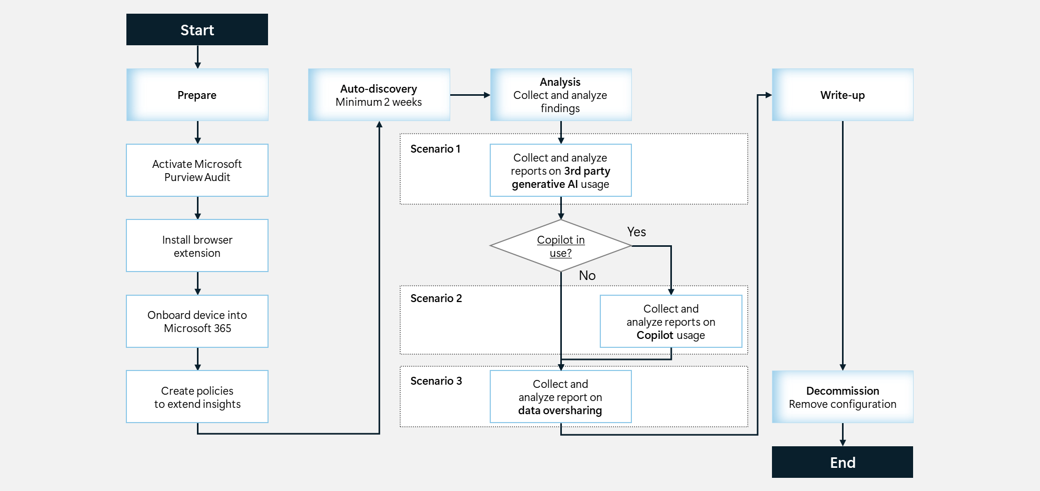

Background reading
For more information refer to:
- Microsoft Purview data security and compliance protections for generative AI apps
- List of AI sites supported by Microsoft Purview Data Security Posture Management for AI
- Permissions for Data Security Posture Management for AI
- How to use Data Security Posture Management for AI

Pre-requisites
Prior to starting the activities in this step, the following mandatory Data Security Check activities as described in <00-Master Delivery Guide> should be completed:
- Step 1 - Kick-off meeting
- Step 2 - Acquire and assign licenses
- Step 3 - Setup and configuration

 Important
Data Security for AI relies on Sensitive Info Types to identify privacy and regulatory risks. Before starting this activity, the instructions outlined in Step 3 - Setup and configuration in the <00-Master Delivery Guide> should be completed successfully. (i.e. all customer specific sensitive information types configured and available).

Verify Microsoft Purview Audit is turned on

Guidance
Microsoft Purview Audit is a comprehensive tool that helps organizations address security events, forensic investigations, internal probes, and compliance requirements. You can use the audit log in the Microsoft Purview portal to monitor user activities across emails, documents, sensitivity labels, and more. Enabling Microsoft Purview Audit is crucial for gaining insights into user interactions with Microsoft Copilot.

Objective(s)
- Enable and run Microsoft Purview Audit

Background reading
For more information refer to:
- Get started with auditing solutions

Instructions
When opening the DSPM for AI dashboard, a list of recommended actions will be presented and the applicable pre-requisites will be verified. Follow the instructions below to confirm the required services are enabled and necessary permissions are assigned.
- Browse to the Microsoft Purview portal at https://purview.microsoft.com/ and log in with Tenant Admin credentials or a user account that is a member of your Data Security Check team and has been assigned the appropriate permissions.
- In the navigation bar on the left side, click on Solutions.
- In the Solutions navigator, click on DSPM for AI
- On the DSPM for AI solution card, click on Overview.
- On the Overview page, below Get started, verify Turn on auditing is checked.
Your screenshot should look similar to the image below.
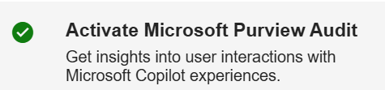

 Important
Do not continue if the pre-requisite is not in place, but revisit the relevant section in the <00-Master Delivery Guide> and use the provided guidance to enable auditing.
.

Install the Microsoft Purview browser extension

Guidance
Browsing and sharing sensitive data with generative AI websites can be a potentially risky user activity. The Microsoft Purview Compliance Extension for Edge, Chrome, and Firefox collects signals that help you detect when these activities occur.

Objective(s)
- Install the Purview browser extension

Background reading
For more information refer to:
- Configure browser signal detection for Microsoft Edge

Instructions
The Purview browser extension is compatible with various internet browsers and offers multiple installation methods, ranging from manual installation to fully automated setup via tools such as Microsoft Intune.
The following instructions outline the procedure for manually deploying the browser extension on a machine running Microsoft Edge x64. For other, more advanced, deployment scenarios, refer to the online documentation at Configure browser signal detection for Microsoft Edge

Important
The Purview browser extension depends on the browser it is installed on. Check Microsoft Edge Browser Requirements before installation and update if needed.

- Browse to the Edge Add-ons webpage at Microsoft Compliance Extension and click Get to download the Microsoft Purview browser extension.
- On the Add “Microsoft Purview Extension” to Microsoft Edge? pop-up windows, click Add extension.
Verify the successful installation.
- Open Microsoft Edge and click on the Ellipsis character (…) in the toolbar.
- In the drop down menu, click on Extensions.
- In the Extensions pop-up, click on Manage extensions.
- Verify the Microsoft Purview Extension is installed and enabled.
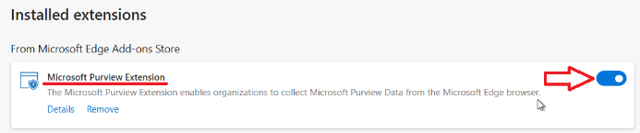

Onboarding devices to Microsoft 365

Guidance
Onboarding user devices to Microsoft Purview allows activity monitoring and enforcement of data protection policies when users are interacting with generative AI apps.
Devices that have already been onboarded to Microsoft Defender for Endpoint will automatically appear in the managed devices list and do not require additional onboarding. To onboard devices that haven't been onboarded yet, an onboarding script needs to be downloaded and deployed to these devices.

Note
The onboarding procedure needs to be executed only once. If devices were onboarded previously, such as for example during the Windows Endpoints module, the instructions in this paragraph can be skipped.

The illustration below provides a high-level overview of the different methods of onboarding devices to Microsoft Purview portal.
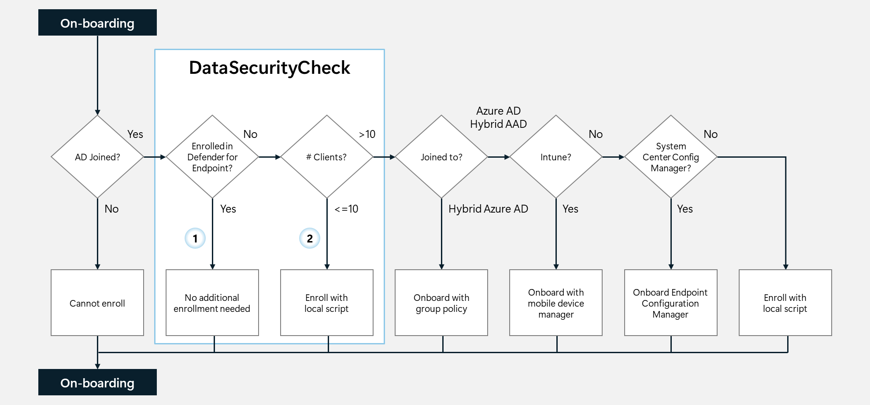
This guide will provide onboarding instructions for:
Option : Endpoints already enrolled in Microsoft Defender for Endpoint.
Option : Endpoints that will be enrolled through the execution of a local script.
For all other onboarding options, refer to Onboard client devices running Windows or macOS to Microsoft Defender for Endpoint.

Objective(s)
- Onboard the endpoints that will participate in the Data Security Check onto the Microsoft Purview portal.

Background reading
- Onboard Windows devices into Microsoft 365 overview
- Windows 10 and Windows 11 Onboarding procedures
- Onboard Windows 10 and Windows 11 devices using a local script

Instructions – Option – Verify endpoint is enrolled in Microsoft Purview portal
Endpoints that have been onboarded to Microsoft Defender for Endpoint, or through the optional Windows Endpoints module, will be listed under managed devices. These devices are actively reporting, and no additional onboarding actions are necessary.
To understand and verify which devices are onboarded, follow the steps outlined below:
- Browse to the Microsoft Purview portal at https://purview.microsoft.com/ and log in with Tenant Admin credentials or a user account that is a member of your Data Security Check team and has been assigned the appropriate permissions.
- In the navigation pane on the left side, click on Settings.
- On the Settings pane, click on Devices onboarding.
- Below Device onboarding click on Devices.
- Verify the devices that will participate in the Data Security Check are listed on the devices overview.
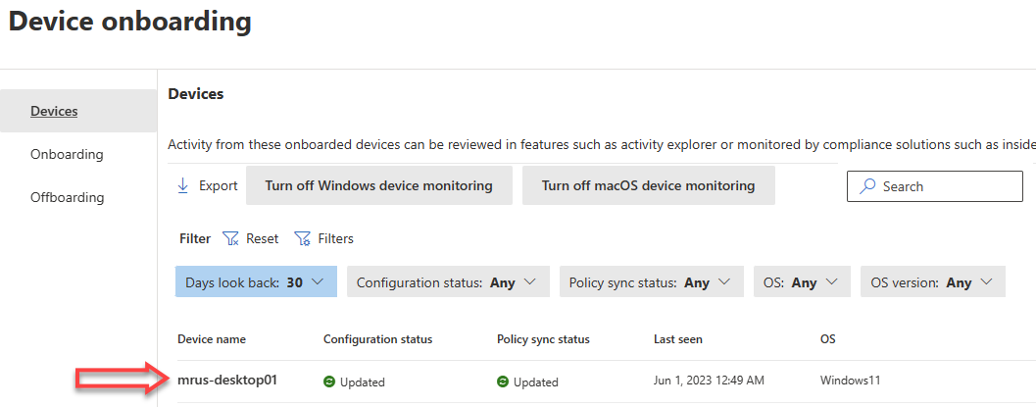

Instructions – Option – onboarding Windows 11 devices using a local script
For customers not using Microsoft Defender for Endpoint or devices that have not (yet) been onboarded, the endpoint has to be onboarded before it can participate in the Data Security Check. This section will describe the steps to onboard a Windows 11 endpoint by executing a local script.
Note
Onboarding devices by using a local script is optimized for onboarding one to ten devices. For alternative onboarding methods, refer to Windows 10 and Windows 11 Onboarding procedures.

- Browse to the Microsoft Purview portal at https://purview.microsoft.com/ and log in with Tenant Admin credentials or a user account that is a member of your Data Security Check team and has been assigned the appropriate permissions.
- In the navigation pane on the left side, click on Settings.
- On the Settings pane, click on Devices onboarding.
- If device onboarding has not been enabled yet, click Turn on device onboarding.
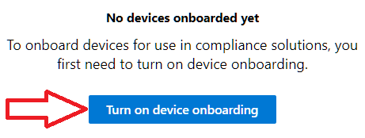
- On the Device monitoring is being turned on pop-up window, click OK.
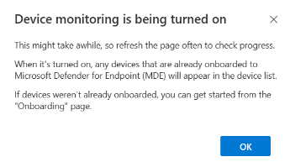

Note
Turning on device onboarding will take time; refresh the page to check progress.

- Below Device onboarding, click on Onboarding.
- Below Select operating system to start onboarding process, select Windows 10.
- Below Deployment method, select Local script (for up to 10 machines).
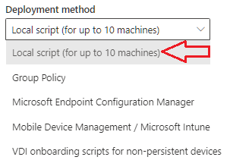
- Click on Download package. This will download the package as a zip file <DeviceComplianceOnboardingPackage.zip> to the default download folder.
- Copy the <DeviceComplianceOnboardingPackage.zip> file to the client workstation that has to be onboarded.
- Extract the contents of the configuration package <DeviceComplianceLocalOnboardingScript.cmd>to a location on the device that needs to be onboarded.
- Go to Start and type Cmd.
- Right click Command prompt and select Run as Administrator.
- Browse to the location of the script file.
- Run DeviceComplianceLocalOnboardingScript.cmd.
- Enter Y to confirm.
- Verify the script completed successfully
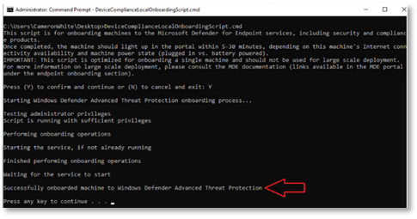
- Close the command prompt.
- Follow the instructions outlined above (Instructions – Option – Verify endpoint is enrolled in Microsoft Purview portal) and check if the device is listed in the Devices overview.

Note
It might take 5-30 min before a newly onboarded device is visible in the Devices overview.

Extend insights for data discovery
DSPM for AI leverages Insider Risk Management , Communication Compliance, and Data Loss Prevention to generate insights for data discovery.
Follow the instructions below to create the required policies:
- DSPM for AI - Detect when users visit AI sites. A Insider Risk Management policy that detects when users use a browser to visit AI sites.
- DSPM for AI : Detect sensitive info added to AI sites. A Data Loss Prevention policy that discovers sensitive content pasted or uploaded in Microsoft Edge (Chrome, and Firefox) to AI sites. This policy covers all users and groups in the organization in audit mode only.
- DSPM for AI - Detect sensitive info shared in AI prompts in Edge. (Pay-as-you-go) Detects prompts sent to generative AI apps in Microsoft Edge and discovers sensitive information shared in prompt contents. This policy covers all users and groups in your organization in audit mode only.

Important
Detecting and protecting cloud app activity with the Edge for Business browser is a pay-as-you-go capability. To detect or protect cloud app activity within the Edge for Business browser, you must first link an Azure subscription for pay-as-you-go billing. Your org will be charged based on usage.
If Pay-as-you-go has not been enabled within the customers organization, the <DSPM for AI - Detect sensitive info shared in AI prompts in Edge policy> will not be created. Refer to Learn about Microsoft Purview billing models for more information.

- DSPM for AI – Unethical behavior in AI apps. (Pay-as-you-go) A Communication Compliance policy that detects sensitive info within prompts and responses in Microsoft 365 Copilot and agents. The policy covers all users and groups in your organization.

Important
When pay-as-you-go is not enabled within the organization, only inappropriate or risky interaction for Microsoft 365 Copilot data will be detected.
To detect inappropriate or risky interactions for non-Microsoft 365 AI data using the <DSPM for AI - Unethical behavior in AI apps> policy in Communication Compliance, you need to enable pay-as-you-go billing in your organization. Non-Microsoft 365 AI data includes information from other generative AI applications from Microsoft and connected external AI applications. This data type includes Copilot in Microsoft Fabric, Microsoft Security Copilot, Microsoft Copilot Studio, and any connected or cloud AI application.
Refer to Subscriptions and billing for more information.

Objective(s)
- Create Data Loss Prevention and Insider Risk Management policies to generate insights into generative AI usage.

Background reading
For more information and further customization, refer to:
- Configure Data Loss Prevention (DLP) policies
- Create and manage insider risk management policies
- Microsoft Purview data security and compliance protections for generative AI apps

Instructions
- Browse to the Microsoft Purview portal at https://purview.microsoft.com/ and log in with Tenant Admin credentials or a user account that is a member of your Data Security Check team and has been assigned the appropriate permissions.
- In the navigation bar on the left side, click on Solutions
- In the Solutions navigator, click on DSPM for AI.
- On the DSPM for AI solution card, click on Overview.
- On the Data Security Posture Management for AI page, below Get started, click Extend your insights for data discovery.
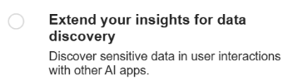
- On the Extend your insights for data discovery fly-out, click Create policies.
- On the Data Security Posture Management for AI page, below Get started, verify the policies have been created successfully.
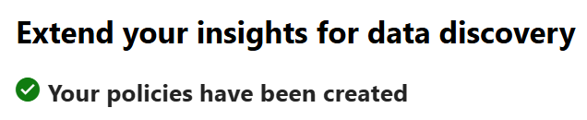

Important
- Policies that have already been created will be skipped, and only policies that do not exist will be created.
- There will be no impact to end users, all created policies will run in audit only mode only.
- Alerts will be generated in Insider Risk Management for potentially risky browsing activity in other AI apps and risky prompts and sensitive responses.
- Browsing events in other AI apps will be shown in Activity Explorer. They won't be anonymized even if anonymization is turned on in Insider Risk Management.

- On the Extend your insights for data discovery fly-out, click X. to close the flyout
Verify the policies have been created.
- On the DSPM for AI solution card, click on Policies.
- On the Policies page, verify the following policies are listed and their status is set to ON.
  - DSPM for AI: Detect sensitive info added to AI sites (Data Loss Prevention)
  - DSPM for AI - Detect when users visit AI sites (Insider Risk Management)

Update the default DSPM for AI Data Loss Prevention policy
The automatically created Data Loss Prevention policy includes a default selection of Sensitive Info Types that are relevant for most customers. Follow the steps below to update the policy to also include the customer specific Sensitive Info Types that you have identified during the Pre-engagement meeting and or Kick-off meeting.
- Browse to the Microsoft Purview portal at https://purview.microsoft.com/ and log in with Tenant Admin credentials or a user account that is a member of your Data Security Check team and has been assigned the appropriate permissions.
- In the navigation bar on the left side, click on Solutions
- In the Solutions navigator, click on Data Loss Prevention.
- On the Data Loss Prevention solution card, click on Policies.
- On the Policies page, select DSPM for AI: Detect sensitive info added to AI sites and click on to Edit the policy.
- On the Name your DLP policy page, click Next.
- On the Assign admin units page, click Next.
- On the Choose where to apply the policy page, click Next.
- On the Customize advanced DLP rules page, next to Audit sensitive data shared to generative AI sites, click  to Edit the DLP rule.
- On the Edit rule page, in the Content contains section, below the Sensitive info types, click Add and select Sensitive info types from the dropdown menu.
- On the Sensitive info types fly-out, search for sensitive info types that start with DataSecurityCheck
- Select all custom sensitive info types that were previously created, click Add.

Important
Carefully inspect all pre-selected Sensitive Info Types, remove the ones that are not applicable and add additional Sensitive Info Types that were identified as relevant by your customer.

- On the Edit rule page, click Save.
- Back on the Customize advanced DLP rules page, click Next.
- On the Policy mode page, verify Turn the policy on immediately is selected and click Next.
- On the Review and finish page, click Submit.
- On the Policy updated page, click Done.

Control unethical behavior in AI
To extend the insights into Microsoft 365 Copilot interactions a Communication Compliance policy will be created. The policy will identify content that matches any of the following trainable classifiers: Regulatory Collusion, Stock manipulation, Unauthorized disclosure, Money laundering, Corporate Sabotage, Sexual, Violence, Hate, Self-harm and covers all users and groups in the organization. If needed the policy can be customized to add additional classifiers or limit the user scope.

Instructions
- Browse to the Microsoft Purview portal at https://purview.microsoft.com/ and log in with Tenant Admin credentials or a user account that is a member of your Data Security Check team and has been assigned the appropriate permissions.
- In the navigation bar on the left side, click on Solutions.
- In the Solutions navigator, click on DSPM for AI.
- On the DSPM for AI solution card, click on Recommendations.
- On the Recommendations page, expand the Recommendation section.
- Below Not Started, click on Detect unethical behavior in AI.
- On the Control unethical behavior in AI flyout, click on Create Policies.
- Click X to Close the Control unethical behavior in AI flyout.
- On the Recommendations page, verify Control unethical behavior in AI is listed below Completed.
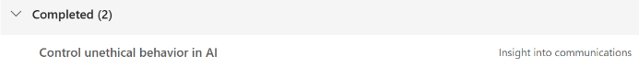
- On the DSPM for AI solution card, click on Policies.
- On the Policies page, verify the DSPM for AI - Unethical behavior in AI apps policy is listed below Communication Compliance and has a status of Activating or On.
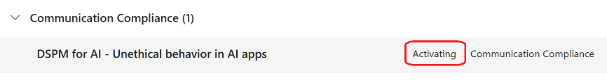

Note
The newly created policy will take some time to appear on the Policies page. Use the Refresh button to update the page.

Note
To gain a clearer understanding of the policy's functions, you can review the details in Communication Compliance by clicking on the newly created policy in the overview in DSPM for AI and then clicking on <Edit policy in solution> in the flyout.

Next step
- Return to the <00-Master Delivery Guide> and continue the guidance provided in Step 3 - Setup and configuration.

Step 4 - Analyze the findings
In Step 4 of the Data Security Check the partner will, together with the customer’s tenant / Compliance Administrator, analyze all logs, information, and reports generated by the different Data Security Check tools and services. This section describes the additional steps required to prepare and analyze the results from the Data Security for AI activity.
It is recommended to do a two-step analysis of the log files, reports, and findings:
- Quick scan. By using the various dashboards and preview views you will be able to identify common patterns and/or trends that need further investigation and can serve as an example of privacy and regulatory risks. Look for “most impactful” events related to important people within the organization, high volumes of documents related to a specific business process, Personally Identifiable Information (PII), etc.
- Detailed analysis. Using exported log and report files for the various services will allow for further investigation of previously identified privacy and regulatory risks and events flagged during the quick scan. Aim at determining the impact and risk and consider possible solutions for mitigation. During this detailed analysis you are advised to leverage the insights of the customer team because they will know what and who to look for. To rule out “false positives” you are advised to do further investigation of all the events that will be included in the final close-out presentation at the end of the engagement.

Guidance
The DSPM for AI dashboard provides a central management location to offer insights into AI usage and potential data security risks. Follow the steps below to collect and analyze key insights, and if necessary, include additional detailed information relevant to your customer.

Objective
- Use the DSPM for AI dashboard to create screenshots to be used in the close out presentation showing how the organization uses third-party public generative AI applications.
- If applicable, create screenshots to illustrate the usage of Microsoft 365 Copilot by users in the organization.
- Analyze the automatically created DSPM for AI Data Assessments to identify overshared data sources.

Background reading
- Microsoft Purview data security and compliance protections for generative AI apps

Pre-requisites
Prior to starting the activities in this step, the following mandatory Data Security Check activities as described in <00-Master Delivery Guide> should be completed:
- Step 1 - Kick-off meeting
- Step 2 - Acquire and assign licenses
- Step 3 - Setup and configuration
- Step 4 - Analyze the findings

Instructions – high level visualization
- On the local workstation, if not already done, extend the previously created directory structure by creating the \DataSecurityCheck\DSPMForAI folder.
- Browse to the Microsoft Purview portal at https://purview.microsoft.com/ and log in with Tenant Admin credentials or a user account that is a member of your Data Security Check team and has been assigned the appropriate permissions.
- In the navigation bar on the left side, click on Solutions
- In the Solutions navigator, click on DSPM for AI.
- On the DSPM for AI solution card, click on Reports.

Important
The following paragraphs provide guidance on how to collect insights generated by DSPM for AI. Not every paragraph will apply to all scenarios. If the scenario you’re working on with your customer is not listed under “Applicable to,” simply skip to the next relevant paragraph.

Total interactions over time (Microsoft Copilot and agents)
Applicable to: Scenario 2 - Microsoft 365 Copilot interactions
- On the Reports page, in the Activity section, navigate to the Total interactions over time (Microsoft Copilot and agents) card.
- Take a screenshot of graphical representation of the findings
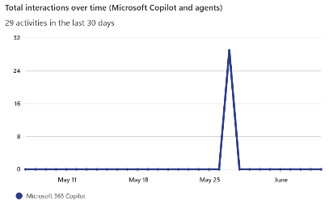

Note
Refer to Use Snipping Tool to capture screenshots for guidance on taking screenshots.

- Save the screenshot as Total interactions over time (Microsoft Copilot).jpg to the \DataSecurityCheck\DSPMForAI folder on your local workstation.

Total visits to 3rd party generative AI apps
Applicable to: Scenario 1 - Shadow AI / 3rd party generative AI
- On the Reports page, in the Activity section, navigate to the Total visits (other AI apps) card.
- Take a screenshot of graphical representation of the findings
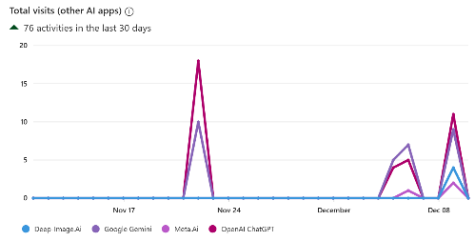
Note
Refer to Use Snipping Tool to capture screenshots for guidance on taking screenshots.

- Save the screenshot as the Total visits other AI apps.jpg to the \DataSecurityCheck\DSPMForAI folder on your local workstation.

Sensitive interactions per AI app
Applicable to: Scenario 1 - Shadow AI / 3rd party generative AI
Scenario 2 - Microsoft 365 Copilot interactions
- On the Reports page, in the Data section, navigate to the Sensitive interactions per AI app card.
- Take a screenshot of graphical representation of the findings
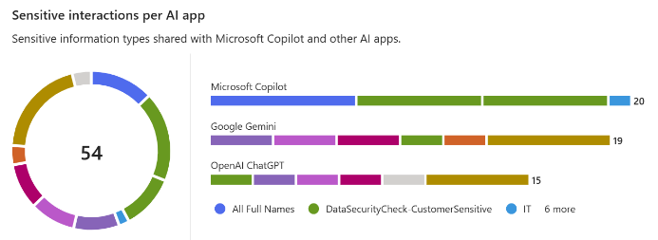
- Save the screenshot as Sensitive Interactions per AI app.jpg to the \DataSecurityCheck\DSPMForAI folder on your local workstation.

Top unethical AI interactions
Applicable to: Scenario 1 - Shadow AI / 3rd party generative AI
Scenario 2 - Microsoft 365 Copilot interactions
- On the Reports page, in the Data section, navigate to the Top unethical AI interactions card.
- Take a screenshot of graphical representation of the findings
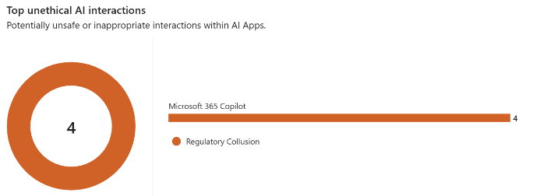
- Save the screenshot as Top unethical AI interactions.jpg to the \DataSecurityCheck\DSPMForAI folder on your local workstation.

Insider risk severity per AI app
Applicable to: Scenario 1 - Shadow AI / 3rd party generative AI
Scenario 2 - Microsoft 365 Copilot interactions
- On the Reports page, in the User section, navigate to the Insider risk severity per AI app card.
- Take a screenshot of graphical representation of the findings
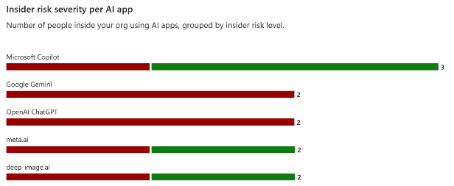
- Save the screenshot as Insider risk severity per AI app.jpg to the \DataSecurityCheck\DSPMForAI folder on your local workstation.

Potential risky AI usage
Applicable to: Scenario 1 - Shadow AI / 3rd party generative AI
Scenario 2 - Microsoft 365 Copilot interactions
- On the Reports page, in the User section, navigate to the Potential risky AI usage card.
- Take a screenshot of graphical representation of the findings
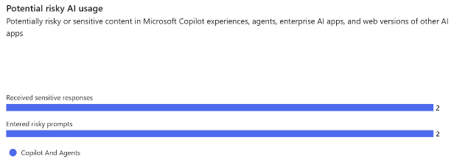
- Save the screenshot as Potential risky AI usage.jpg to the \DataSecurityCheck\DSPMForAI folder on your local workstation.

Data risk assessments
Applicable to: Scenario 3 - Identify data oversharing risks

- On the DSPM for AI solution card, click on Data risk assessments.
- On the Default assessment card, click on View details
Important
The default data risk assessment runs automatically every week. Depending on the volume of data stored in the customer's tenant, it may take from one to several days to complete. If a default assessment has not yet been generated, the Default Assessment card will provide an indication when insights are expected to become available.
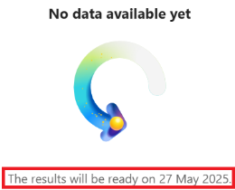

- On the Default assessment dashboard, take a screenshot of the Total items card.
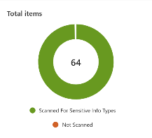
- Save the screenshot as Default Assessment- Total items MMM DD, YYYY.jpg to the \DataSecurityCheck\DSPMForAI folder on your local workstation.
- On the Default assessment dashboard, take a screenshot of the Sensitivity labels on data card.
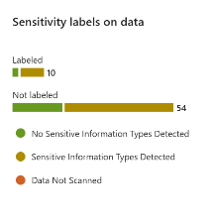
- Save the screenshot as Default Assessment- Sensitivity Labels MMM DD, YYYY.jpg to the \DataSecurityCheck\DSPMForAI folder on your local workstation.
- On the Default assessment dashboard, take a screenshot of the Items shared with card.
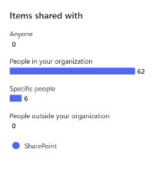
- Save the screenshot as Default Assessment- Items shared MMM DD, YYYY.jpg to the \DataSecurityCheck\DSPMForAI folder on your local workstation.

Note
Depending on the tenant location and version, the Items shared with card may have been replaced by the Sharing links accessed by anonymous or external users (last 30 days) card.
If the Items shared with card is not available within the customers tenant, replace it with a screenshot of the Sharing links accessed by anonymous or external users (last 30 days) card,

- On the Default assessment dashboard, below Data risk assessment results, click on Export.
- On the Export dfata risk assessment results fly-out, click on Excel.
- Verify both Column Headers and Summary sheet are selected.
- Below Data, select All items, unfiltered.
- Below File name, specify \DataSecurityCheck\DSPMForA\Report_Defaultassessment_yyyy-mm-dd.xlsx as the file name and click Export.

Instructions – Detailed analysis
The View details button in the Reports dashboard gives access to detailed information related to the high level graphs on the reports page. Clicking View details opens the Activity explorer with preset filters that will assist in further analysis and exploration. If high data risks or suspicious user behavior is detected, use the activity explorer for more investigation and copy the findings to the <41-Close out deck>.
The illustration below shows an example of the additional information the Activity explorer can provide and that can be used for further investigation.
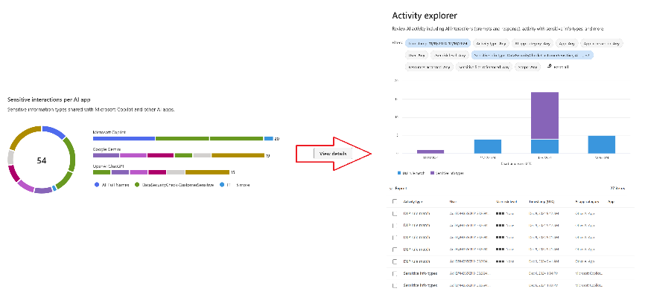

Next step
- Return to the <00-Master Delivery Guide> and continue the guidance provided in Step 4 - Analyze the findings.

Step 6 - Decommission

Guidance
The final activity for the Data Loss Prevention for Endpoints activity is to decommission the services and tools used for this activity.
Important
Do not perform the decommissioning steps, if the customer chooses to do so, until after the Proof of Execution (POE) has been filled out. The POE requires that evidence of the configuration is captured and will not be able to be completed if all of the policies are removed.

Objectives
The objectives for this activity are:
- Decommission the services that were installed to support the Data Loss Prevention for Endpoints.
- Offboard all endpoints that were manually onboarded to the Data Loss Prevention for Endpoints service.

Deliverables
For this activity, the following deliverables have been defined:
- All tools and services used during the Data Loss Prevention for Endpoints activity are decommissioned.
- All custom configuration artifacts are removed from the customer’s tenant.
- All manually onboarded endpoints are offboarded from the service.

Instructions – Turn off device monitoring
- Browse to the Microsoft Purview portal at https://compliance.microsoft.com and log in with one of the accounts that is assigned the Compliance Administrator role in the previous paragraph.
- In the navigation pane on the left side, click on Settings.
- On the Settings pane, expand Device onboarding.
- Below Device onboarding, click on Devices.
- Below Devices, click on Turn off Windows device monitoring.
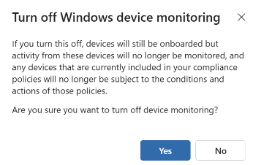
- Click Yes.

Instructions – Offboard endpoints
- Browse to the Microsoft Purview portal at https://compliance.microsoft.com and log in with one of the accounts that is assigned the Compliance Administrator role in the previous paragraph.
- In the navigation pane on the left side, click on Settings.
- On the Settings pane, expand Device onboarding.
- Below Device onboarding, click on Offboarding.
- Below Select operating system to start onboarding process, verify Windows 10 is selected.
- Below Deployment method, select Local script (for up to 10 machines).

- Click on Download package. This will download the package as a zip file (DeviceComplianceOffboardingPackage_valid_until_YYYY-MM-DD.zip) to the default download folder.
- Copy the DeviceComplianceOffboardingPackage_valid_until_YYYY-MM-DD.zip file to the client workstation that has to be offboarded.
- Extract the contents of the configuration package (DeviceComplianceOffboardingScript_valid_until_YYYY-MM-DD.cmd) to a location on the device that needs to be offboarded.
- Go to Start and type Cmd.
- Right-click Command prompt and select Run as Administrator.
- Browse to the location of the script file.
- Run DeviceComplianceLocalOnboardingScript_valid_until_YYYY-MM-DD.cmd.
- Verify the script completed successfully.
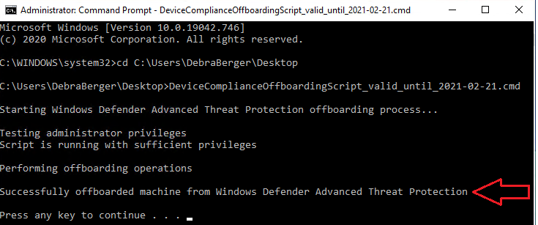
- Close the command prompt.

Note
For additional information on offboarding devices refer to Offboard devices.

Instructions – Delete the DSPM for AI Data Loss Prevention policies
- Browse to the Microsoft Purview portal at https://purview.microsoft.com/ and log in with Tenant Admin credentials or a user account that is a member of your Data Security Check team and has been assigned the appropriate permissions.
- In the navigation bar on the left side, click on Solutions.
- In the Solutions navigator, click on Data Loss Prevention.
- On the Data Loss Prevention solution card, click on Policies.
- On the Policies page, select the DSPM for AI: Detect sensitive info added to AI sites policy.
- Click on Delete Policy ().
- On the Delete DLP policy pop-up, click on Delete Policy.

Instructions – Delete the DSPM for AI Insider Risk Management policies
- Browse to the Microsoft Purview portal at https://purview.microsoft.com/ and log in with Tenant Admin credentials or a user account that is a member of your Data Security Check team and has been assigned the appropriate permissions.
- In the navigation bar on the left side, click on Solutions.
- In the Solutions navigator, click on Insider Risk Management.
- On the Insider risk management solution card, click on Policies.
- On the Policies page, select the DSPM for AI - Detect when users visit AI sites policy.
- Click on Delete ().
- On the Delete “DSPM for AI – Detect when users visit AI site” pop-up, select Delete the policy and all associated alerts and users.
- Click on Delete.
- On the Confirm you want to delete…. popup, click Confirm.

Instructions – Delete the DSPM for AI Communication Compliance policies
- Browse to the Microsoft Purview portal at https://purview.microsoft.com/ and log in with Tenant Admin credentials or a user account that is a member of your Data Security Check team and has been assigned the appropriate permissions.
- In the navigation bar on the left side, click on Solutions.
- In the Solutions navigator, click on Communication compliance.
- On the Data Loss Prevention solution card, click on Policies.
- On the Policies page, select the DSPM for AI – Unethical behavior in AI apps policy.
- Click on Delete ().
- On the Delete this policy? Fly-out, click Delete.
- Click Close.

Next step
- Return to the <00-Master Delivery Guide> and continue the guidance provided in Step 6 - Decommission.

